# 2. Git-HOL

I learned the following in this hands-on lab:

- Explain git ignore

- Ignore unwanted files using .gitignore

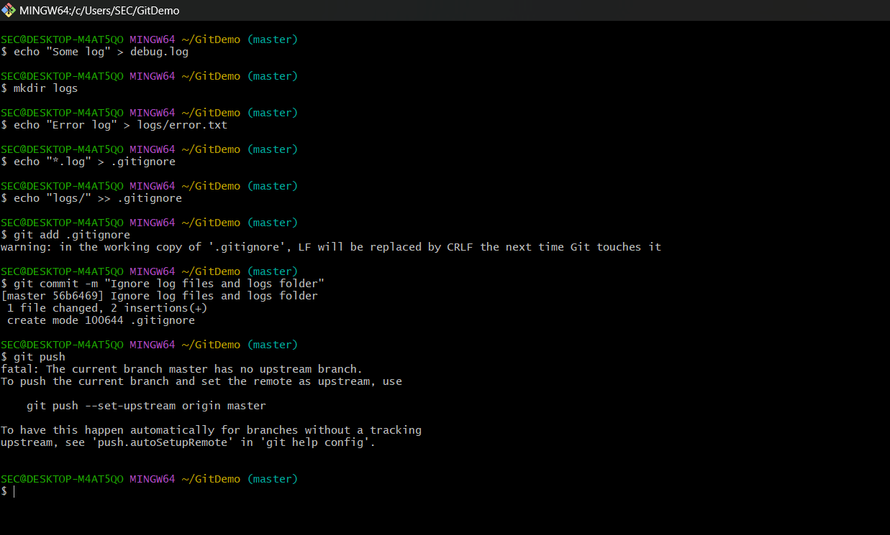  
Summary of what I did:

Created unwanted log files and folders, updated .gitignore to exclude them, committed changes, and verified that Git ignored the specified files.